**FLUTTER POST DATA TO API – SAMPLE REST API**

Steps:

1. Open Android Studio, Click New Flutter Project
2. Add http package
3. Create Api Class
4. Import the package on the Api class page.
5. Create form widgets and import Api class.
6. Open Android Studio and Click New Flutter Project.

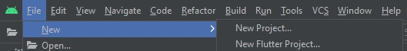

1. Add http package

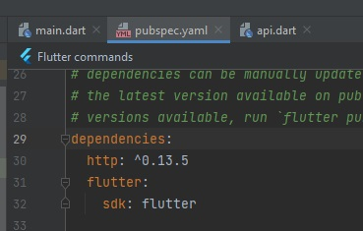

1. Create Api Class

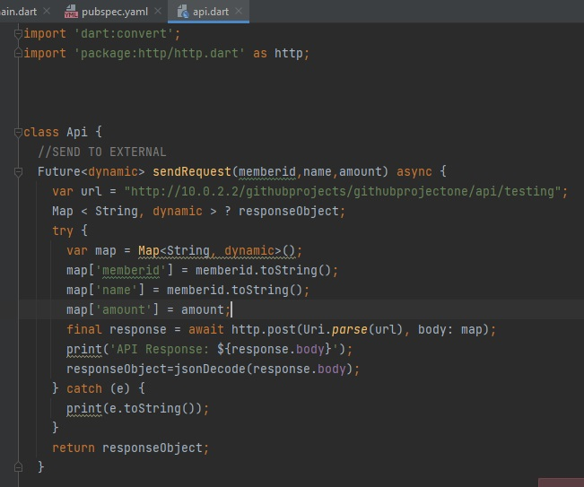

1. Import the http package into the Api Class
2. Create Form widgets

Complete code

import 'package:flutter/material.dart';  
import 'api.dart';  
void main() {  
 runApp(const MyApp());  
}  
  
class MyApp extends StatelessWidget {  
 const MyApp({Key? key}) : super(key: key);  
  
 // This widget is the root of your application.  
 @override  
 Widget build(BuildContext context) {  
 return MaterialApp(  
 debugShowCheckedModeBanner: false,  
 title: 'Flutter Demo',  
 theme: ThemeData(  
   
 primarySwatch: Colors.*blue*,  
 ),  
 home: const MyHomePage(title: 'REST API'),  
 );  
 }  
}  
  
class MyHomePage extends StatefulWidget {  
 const MyHomePage({Key? key, required this.title}) : super(key: key);  
 final String title;  
  
 @override  
 State<MyHomePage> createState() => _MyHomePageState();  
}  
  
class _MyHomePageState extends State<MyHomePage> {  
  
 TextEditingController _amountTextCtrl = new TextEditingController();  
 TextEditingController _nameTextCtrl = new TextEditingController();  
 TextEditingController _idTextCtrl = new TextEditingController();  
  
 @override  
 Widget build(BuildContext context) {  
  
 return Scaffold(  
   
 appBar: AppBar(  
   
 title: Text(widget.title),  
 ),  
 body: SingleChildScrollView(  
  
 child: Column(  
  
 // horizontal).  
 mainAxisAlignment: MainAxisAlignment.center,  
 children: <Widget>[  
 SizedBox(height:10,),  
 Center(child:  
 Text(  
 'SEND DATA TO API',  
 ),),  
 Padding(  
 padding: const EdgeInsets.symmetric(horizontal: 38,),  
 child: TextFormField(  
 controller: _idTextCtrl,  
 decoration: const InputDecoration(  
 border: UnderlineInputBorder(),  
 labelText: 'Enter your ID',  
 ),  
 ),  
 ),  
 Padding(  
 padding: const EdgeInsets.symmetric(horizontal: 38),  
 child: TextFormField(  
 controller: _nameTextCtrl,  
 decoration: const InputDecoration(  
 border: UnderlineInputBorder(),  
 labelText: 'Enter your Name',  
 ),  
 ),  
 ),  
  
 Padding(  
 padding: const EdgeInsets.symmetric(horizontal: 38),  
 child: TextFormField(  
 controller: _amountTextCtrl,  
 decoration: const InputDecoration(  
 border: UnderlineInputBorder(),  
 labelText: 'Enter your Money',  
 ),  
 ),  
 ),  
  
 Container(  
 margin: EdgeInsets.all(25),  
 child: FlatButton(  
 child: Text(  
 'SUBMIT TO API NOW ',  
 style: TextStyle(fontSize: 20.0),  
 ),  
 color: Colors.*cyan*,  
 textColor: Colors.*black*,  
 onPressed: () async {  
   
 await Api().sendRequest(_idTextCtrl.text,_nameTextCtrl.text,_amountTextCtrl.text).then((res){  
  
 Map<String,dynamic> result = res;  
 //API RESPONSE  
 print(result);  
 final snackBar = SnackBar(content: Text(result.toString()));  
 ScaffoldMessenger.*of*(context).showSnackBar(snackBar);  
   
 });  
 print('You clicked Me!');  
   
 },  
 ),  
 ),   
   
   
 ],  
 ),  
 ),  
  
 );  
 }  
}

Output:

